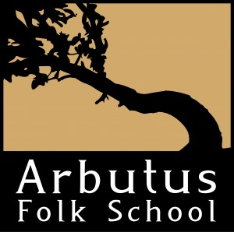 Arbutus Folk School Board of Directors
Application for Board Membership

NAME: _____________________________________________________________________________________________________________

HOME ADDRESS: _________________________________________________________________________________________________

PROFESSION/TITLE: _____________________________________________________________________________________________

BUSINESS NAME: _________________________________________________________________________________________________

PHONE 1: _______________________________________ PHONE 2: __________________________________________

EMAIL ADDRESS: _________________________________________________________________________________________________

Areas of Interest - Occupational/Professional skills and/or experience (check all that apply)
____ Arts/Crafts  ____ Architecture  ____ Administration  ____ Board Development  ____ Business/Corporate  ____ Community Service  ____ Construction/Bldg. Trades  ____ Education  ____ Engineering  ____ Facility Management | ____ Finance-Accounting/Bank  ____ Fund Raising  ____ Government Relations  ____ Health Care  ____ Homemaker  ____ Human Resources  ____ Information technology  ____ Law  ____ Marketing/Public Relations  ____ Policy Analysis/Development | ____ Program Develop/Manage  ____ Project/Event Management  ____ Real Estate  ____ Research  ____ Strategic Planning  ____ Technology  ____ Other: ________________________  ____ Other: ________________________  ____ Other: _______________________

Experience: The majority of your experience is in:
____ Public Sector (Federal/State/City/County) ____ Private Sector ____ Non-Profit

Areas of Community Connection (please check all that apply and write in specific connection)
___ Corporate ___________________________________________________________________________________________________
___ Cultural Organizations ______________________________________________________________________________________
___ Civic/Service Groups ______________________________________________________________________________________
___ Education ___________________________________________________________________________________________________
___ Government ________________________________________________________________________________________________
___ Health Care Provider______________________________________________________________________________________
___ Media _______________________________________________________________________________________________________
___ Philanthropy _______________________________________________________________________________________________
___ Religions Organizations ___________________________________________________________________________________
___ Small Business _____________________________________________________________________________________________
___ Social Services Organizations ______________________________________________________________________________
___ Tribal Organizations _________________________________________________________________________________________
Please list any previous experience with organizational boards:

What strengths would you bring to the Arbutus Folk School Board of Directors?

Why are you motivated to become an Arbutus Folk School board member?

Signature: _____________________________________________________________________ Date: ____/____/____

THIS SECTION TO BE COMPLETED BY THE EXECUTIVE COMMITTEE
Decision:
____ Approved
____ Not interested at this time
____ Retain for future contact. Possible timeframe: ______________________________________________________________
____ Contact candidate to complete application
Who will contact? __________________________________________________________________________________________

Notes

